Wind Erosion and Desert Landforms Name:
Unit 2: Gradational Processes Period:
Geography 12

A desert area is one in which the annual rainfall is not sufficient to maintain a continuous cover of vegetation. Still, with the haphazard occurrence of rainfall and prolonged period of drought, another agent, the wind, has an opportunity to play a major part in the creation of desert landforms.

With few plants to anchor the debris and little vegetation to restrict air movements, the strong winds of the desert are able to whip up the smaller rock fragments and carry them along. This process creates distinct features associated with arid areas.

Deserts of the World

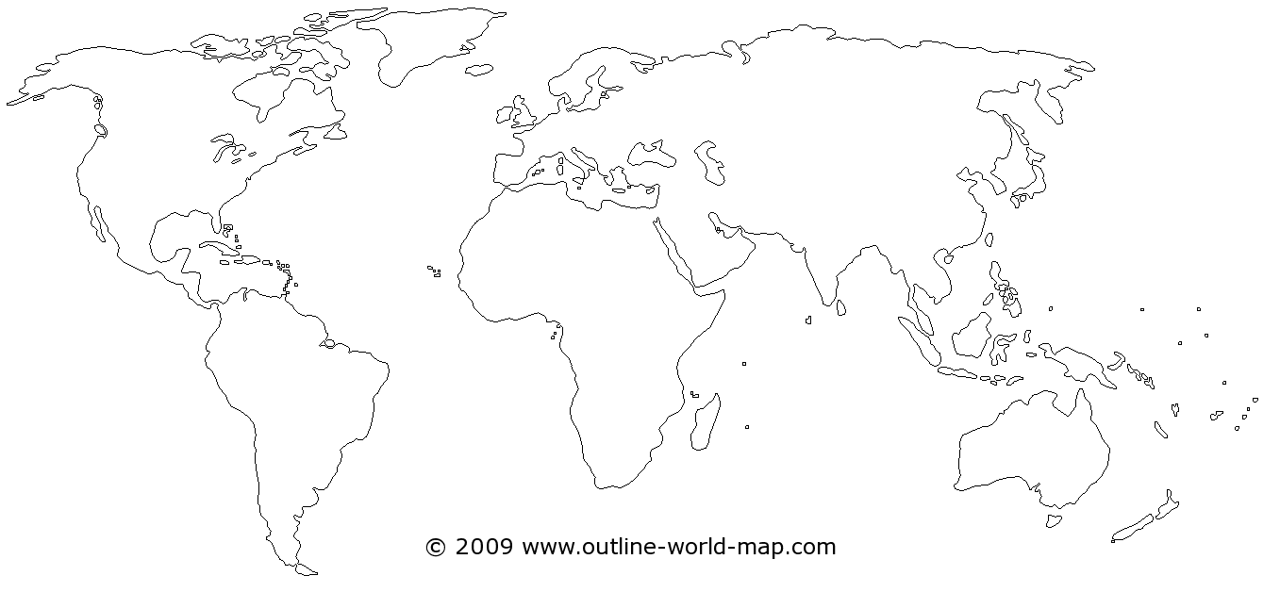

Factors that cause desert regions:
- Latitude
- Cold Ocean Currents
- Ocean influence
- Mountain barriers
Deserts and Wind Action
- Strong winds carry light surface materials are carried by ____________________.
- Movement of sand in the desert is largely by __________________ particles roll and bounce along the ground.

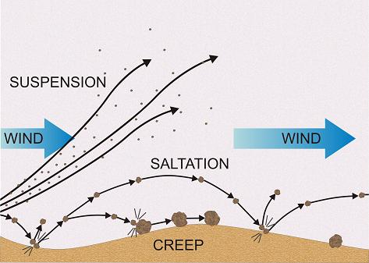

- Moving sand can have an __________________ power on existing landforms.
- Strongest close to the ground and create features called ______________________

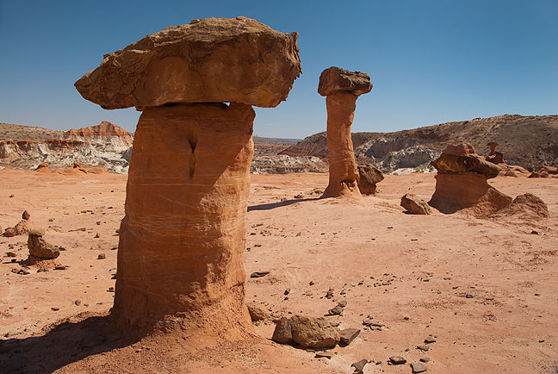

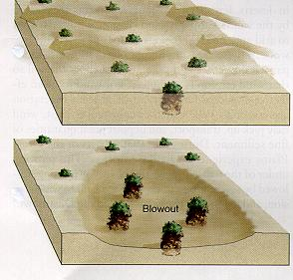
Deflation
- Refers to wind blowing away sand, silt and clay in deserts so that underlying rocks become exposed.
- The resulting landforms are deep hollows called ______________ and stony landscapes called badlands.

Sand dunes
- as wind blows sand over the desert landscape, deposits of sand may collect against some obstruction like a boulder and over time a sand dune will take shape.
- Long, gentle slope on windward side and steep slope on leeward side slip face.
- Dune Migration: long gentle slope on windward slope and roll or slide down to the slip face
- In areas where winds blow the same direction dunes migrate.

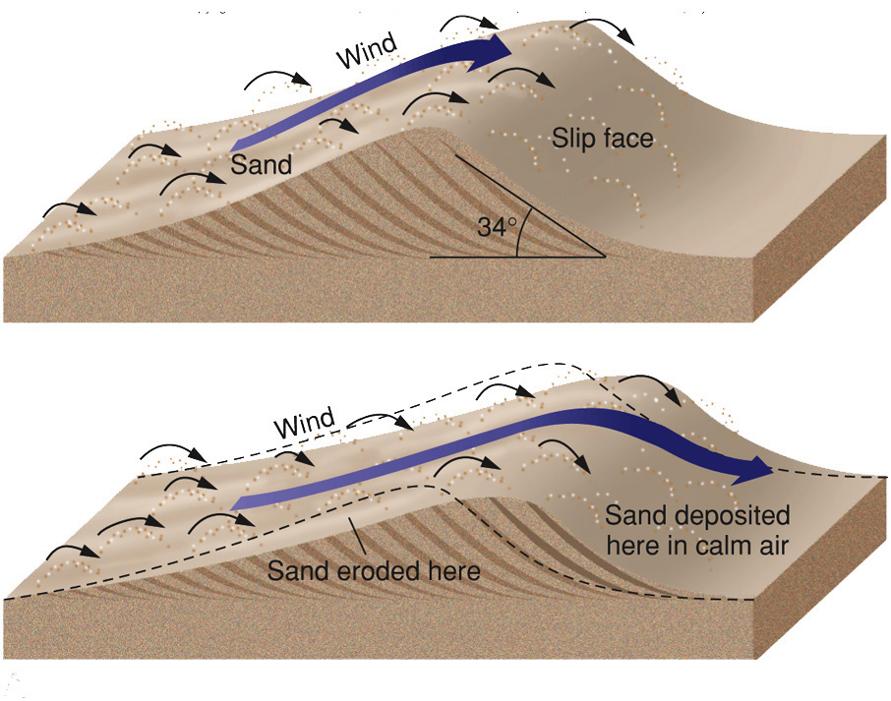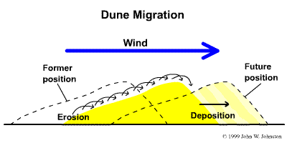

Types of Sand Dunes

Dune Type | Formation | Diagram
Transverse | - Abundant sand needed  - Continuous sand ridge forms at right angles to wind
Barchan | - Crescent shaped  - Forms over small boulder  - Horns point downwind  - Sand blows up the windward slope and slides down the slip face
Parabolic | - Crescent shaped  - Horns point up wind  - Vegetation anchors the horns
Longitudinal | - Found in deserts where only a thin layer of sand is present  - Winds blow continuously in one direction  - Long and straight parallel to the wind

Desert Landforms:

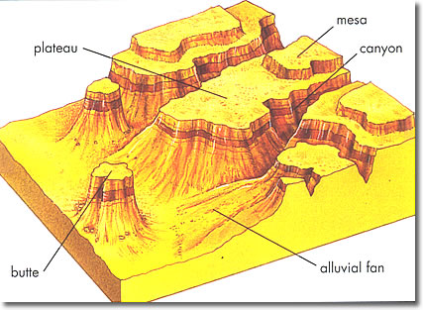

A) label and define the following features on the diagram provided:
- Plateau
- Canyon
- Butte
- Alluvial fan
- Playa
- Mesa
- Bolson
- Erg
b) add the four types of sand dunes and wind direction on the diagram provided:

