Structures of the Earth’s Surface
Unit 2: Tectonic Processes
Geography 12

- Extrusive Forms: when magma flows out onto the surface it is said to extrude structures are called extrusive forms.
- Intrusive Forms: magma that penetrates the lithosphere and does not reach the surface. It solidifies in cracks intrudes upon overlying rocks structures are intrusive forms.

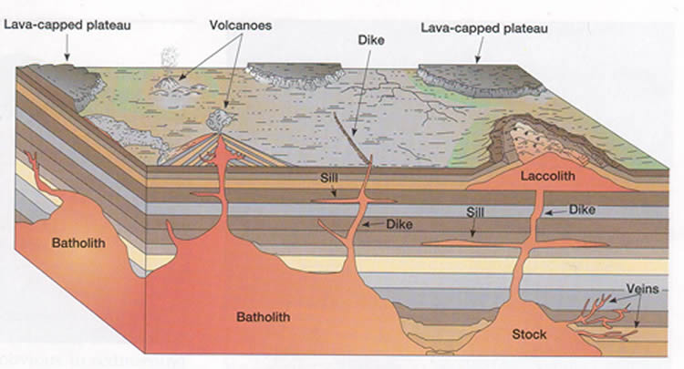

Deformation of the Earth’s Surface

Faulting and Folding
- Forces of ___________________________________ (pushing together) and _________________________________ (pulling apart) play a role in the folding and faulting of rock layers.
- Upfolds ________________________________
- Downfolds _____________________________

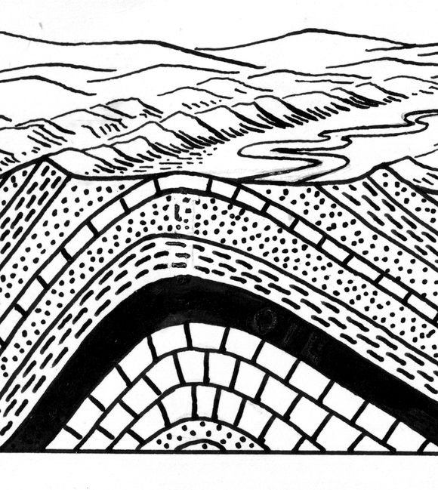
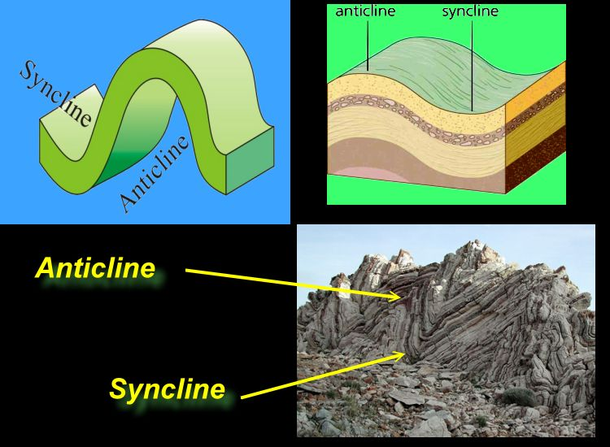

Landforms produced by faulting:

1. Normal Fault
2. Reverse Fault

3. Rift Valley or Graben
4. Block Mountain or Horst

Post Lecture Questions:

Identify the features at locations 1 though 10 using the following terms: batholith, fissure, lava flow, volcanic ash, laccolith, sill, dike, stock, volcano, volcanic chamber.

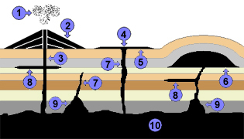

1.
2.
3.
4.
5.
6.
7.
8.
9.
10.

