Running Water 2 Name:
Unit 3: Gradation Period:
Geography 12

Three Stages of River Development
- Youth Stage (upper course)
- Mature Stage (middle course)
- Old Age Stage (lower course)

1. Youth Stage
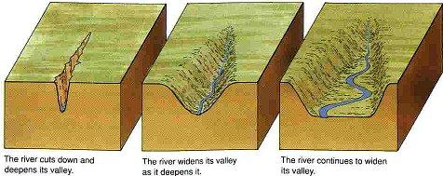
- Vertical erosion is the river’s main work at this stage.
- River cuts a deep _________
______________________ or canyon via hydraulic action and corrosion
- As river moves downstream the banks are susceptible to freeze –thaw action.

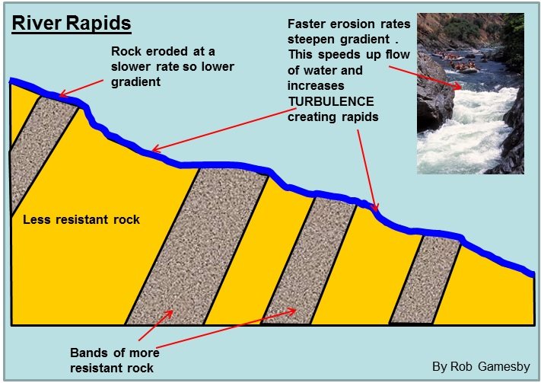
- Rapids are areas along the rivers course where water becomes more turbulent

- Created when the river flows over alternating bands of harder and softer rocks.

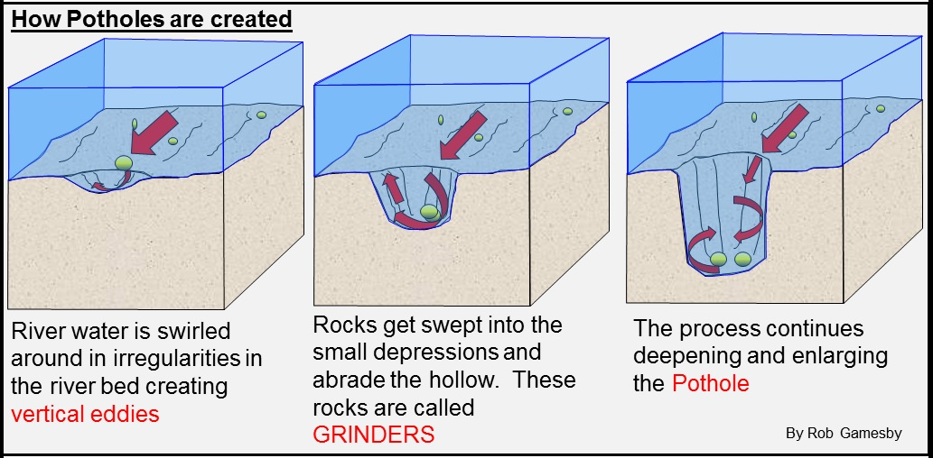
- Potholes are found along the river bed.
- Created via abrasion.
Waterfalls

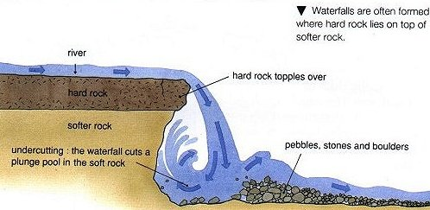

2. Mature Stage
- Vertical erosion continues + _______________________________
- Velocity of flow slows and deposition of river sediment is common.
- Speed of river slows and can be used as a transportation route.

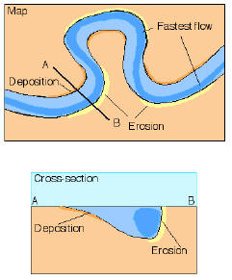
Meanders: river slows, lateral erosion begins to take place and river starts to wind.
- Point of erosion: ____________
- Point of deposition: _________
___________________________

3. Old Age Stage
- Large, slow moving stream on flat land.
- Flood plain and meanders continue to widen.
- Slow moving river is forced to deposit its load. Usually along the flood plain ___________________________________

Levees
- As river overflows its banks, it deposits material _____________ form along the banks.

- Flat flood plain ideal for farming but subject to flooding artificial levees built to prevent flooding damage.

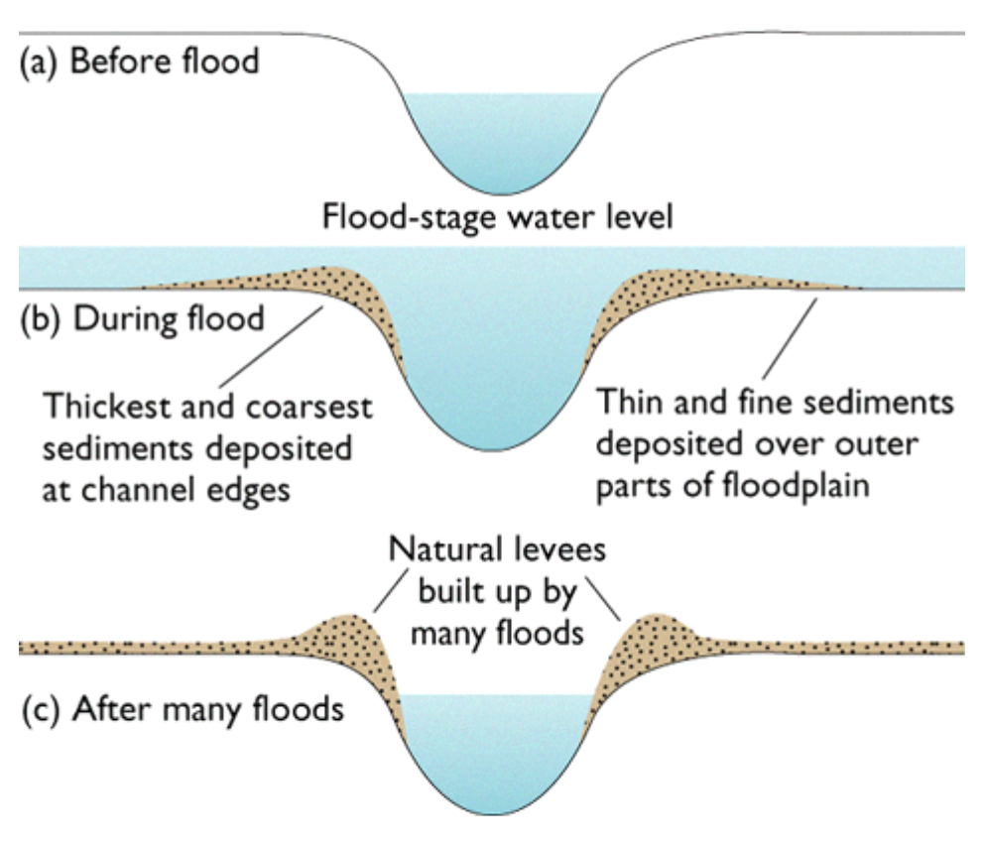

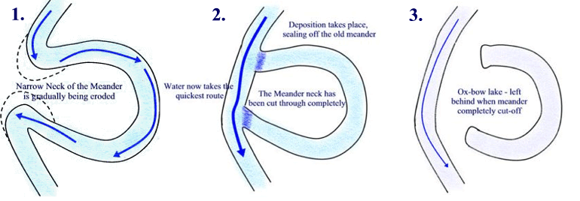
Meanders and Oxbow Lakes
- As meanders widen the river can cut across meanders to create _________________

