Running Water: Rivers Name:
Unit 2: Gradational Processes

Water can create unique landforms around the world. For example, wherever significant amounts of precipitation fall on the earth’s surface, the work of running water shapes and reshapes the land, wearing down tough rough spots and filling in hollows.

Rivers are born in upland areas and can be classified as streams when water begins to accumulate and follow a definite course.

River Anatomy:

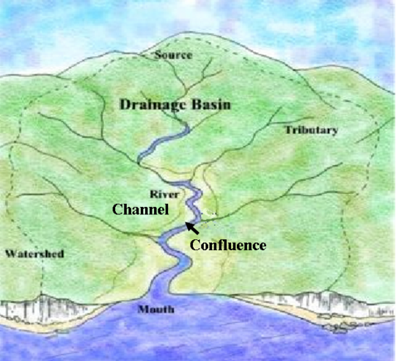

Key Terms: drainage basin, watershed, head (source), tributary, river, confluence, bed, flood plain, river valley, mouth
Erosional action of rivers

Hydraulic action | - Force of water has great power.  - Material is worked loose from banks and riverbed then carried _______________________________________________.  - Greater the velocity the greater the erosion
Abrasion | - Debris and sand have an abrasive effect on river banks and river beds.  - Rocks look polished by the abrasive power of the river’s load
Attrition | - When water moves fast, rocks of varying sizes are moved along by the river and they repeatedly strike other rocks ______  _______________________________________________.
Corrosion | - Rivers are mildly _____________ and some rocks are _______________ in water and transported.

Ways that rivers transport sediments:

Solution: | Suspension:
Traction: | Saltation:
