Introduction to Weather and Climate Name:
Unit 3: Weather and Climate
Geography 12

Weather | Climate

Climate Controls
- Factors that play a key role in influencing climatic conditions like temperature.
- These factors are closely linked and interdependent.

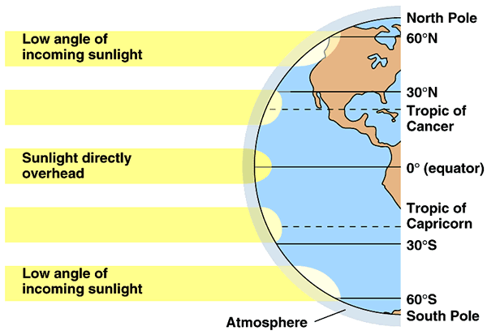
1. Latitude:

- Latitude controls both the angle at which the sun’s rays strike and the duration of the period of daylight determine that amount of ____________________________________ received.

2. Altitude:
- As one ascends the temperature drops b/c incoming UV rays are reflected and absorbed by the earth air cools as it rises.
- As altitude increases, temperature decreases.
- __________________________________ for every 1000m temperature drops 6.5 degrees C.

3. Distribution of land and water
- Land and water heat and cool at different rates.
- Water heats slowly, but retains heat for a long time vs. land heats and cools rapidly.
- This creates: ____________________________________ in places close to the ocean and ______________________________________ in places far inland.

4. Prevailing Winds:
- Winds from oceans will bring mild temperatures and winds from land will bring extreme cold or hot temperatures.

5. Clouds:
- During the day: earth is heated by the sun.
- If skies are clear, more heat reaches the earth's surface. This leads to warmer temperatures.
- If skies are cloudy, some of the sun's rays are reflected off the cloud droplets back into space. Therefore, less of the sun's energy is able to reach the earth's surface, which causes the earth to heat up more slowly. This leads to cooler temperatures.

- At night: if clouds are present, some of the heat emitted from the earth's surface is trapped by the clouds and reemitted back towards the earth. As a result, temperatures decrease more slowly than if the skies were clear.

6. Mountain Barrier
- Mountains create moist areas on windward side and dry areas on the leeward side creating a ______________________________________.

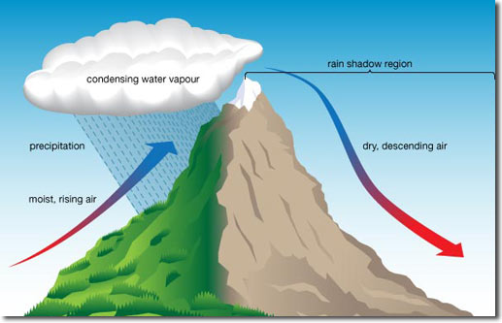

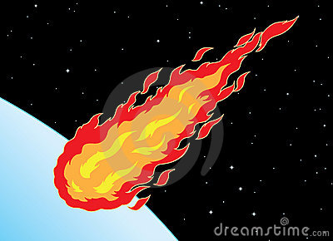
Atmosphere Basics

1. Label the layers of the atmosphere, the pauses, the ozone layer, and Jetstream on the blank diagram. Be sure to include temperature and height above sea level.

2. Name at least 3 things our atmosphere does for us:

1.

2.

3.

3. Name at least 4 other gases in the atmosphere besides oxygen and nitrogen:

1.
2.
3.
4.

4. How is the lower part of the earth warmed?

5. Explain how the atmosphere is like a greenhouse. What parts of it function as a glass?

